Modern World History 1500-1815
Picture collage of places we have visited in Modern World History
Renaissance
The Renaissance was a rebirth of Greco-Roman ideas. Two of the most famous artists of the Renaissance were Da Vinci and Michelangelo. Da Vinci was known for painting The Last Supper and the Mona Lisa. On the other hand, Michelangelo would be known for painting the Sistine Chapel. During the Renaissance, artists would portray the lifelike features of humans.
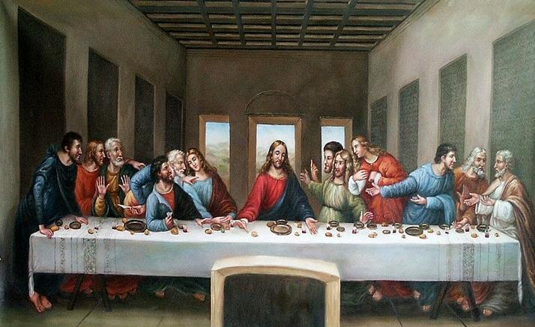
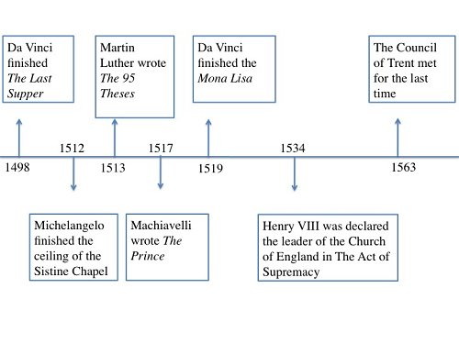
The intellectual side of the Renaissance was based on the philosophy known as humanism. The following three points summarize humanism:
- Secular Movement-A movement away from the Catholic Church
- Stressed individualism and the individual achievement
- A questioning attitude
Machiavelli was a political philosopher during the Renaissance. In the early 16th century, Machiavelli wrote The Prince, a book of political advice on how a leader should obtain and maintain power. His message was a ruler should implement any policy to stay in power as long "as the ends justify the means."
Machiavelli Martin Luther
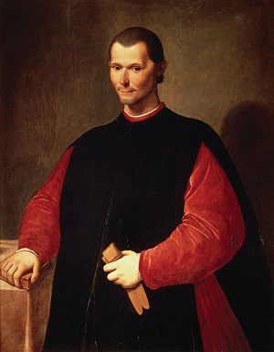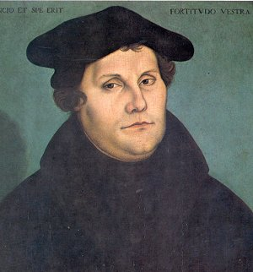

The Protestant Reformation was a movement sparked by Martin Luther and the 95 Theses. Luther argued the sale of indulgences was a corrupt practice in the Catholic Church. He would be the founder of a new Christian denomination new known as Lutheranism. Luther was not alone in creating a denomination of Christianity; John Calvin would develop a form Protestantism known as Calvinism.
In the mid 15h century, Johannes Gutenberg would invent the moving type printing press. This would be key in spreading the ideas of the Reformation.

Henry VIII
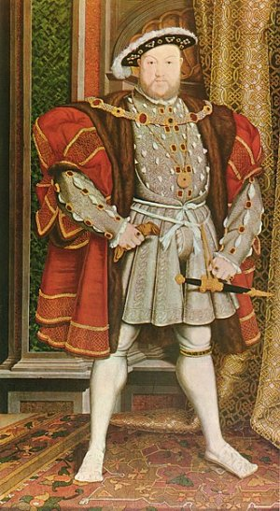

Henry VIII was the King of England during the Protestant Reformation. Henry wanted to divorce his wife since she did not give him a male heir to the throne. When the Pope refused to grant Henry's request, Henry broke away from the Catholic Church and established the Anglican Church. The move away from the Catholic Church would be finalized in The Act of Supremacy.
Council of Trent-This was the Catholic Church's response to the Reformation. This is part of what is known as the Counter Reformation.

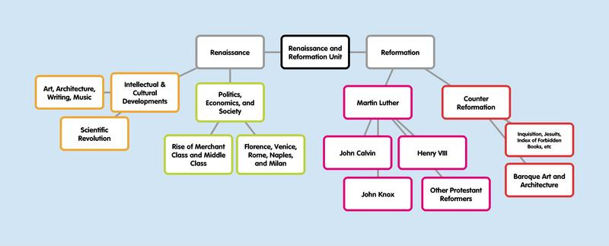
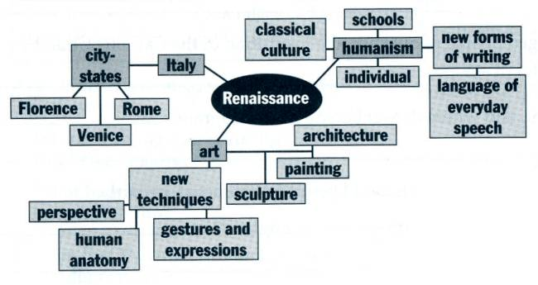
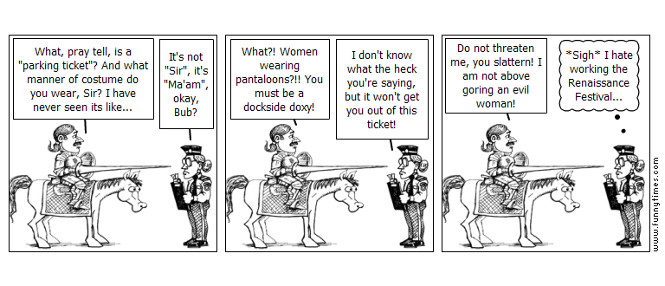

Ottoman, Mughal and Safavid Empires
“The Gunpowder Empires”
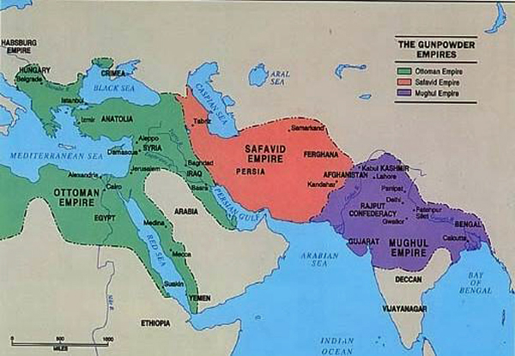
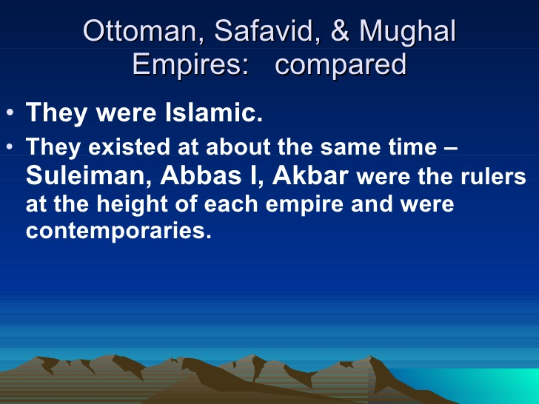
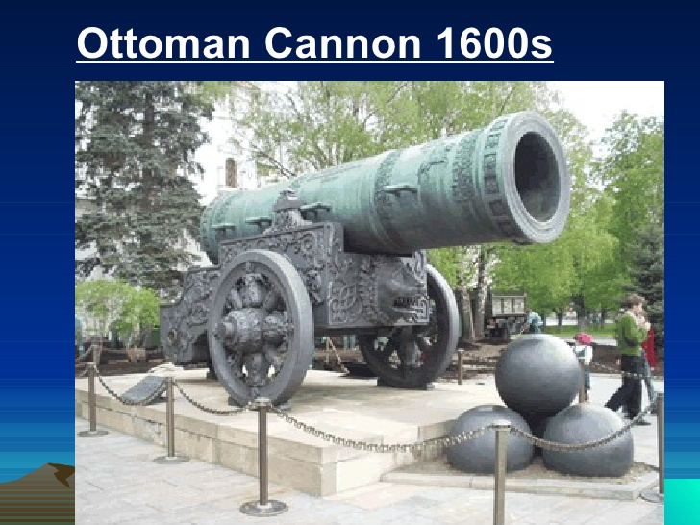
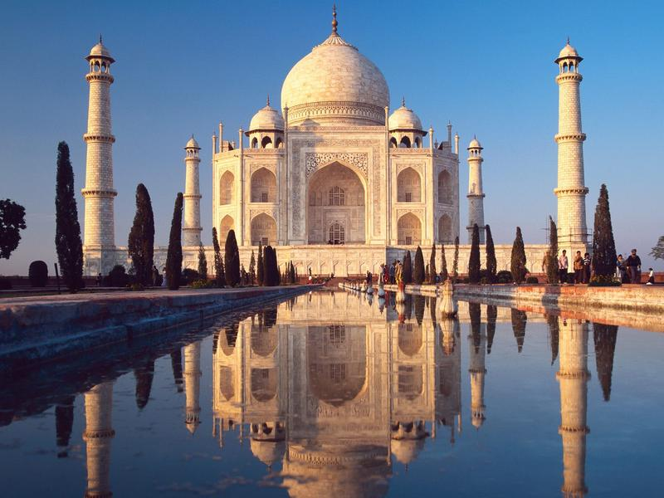
The Age of Exploration and Isolation
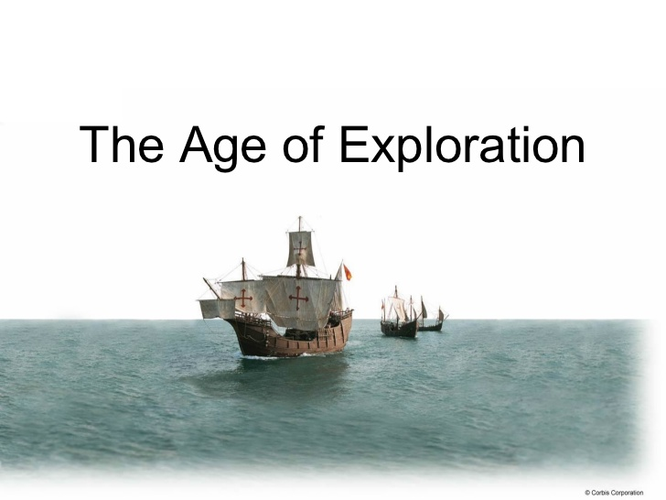
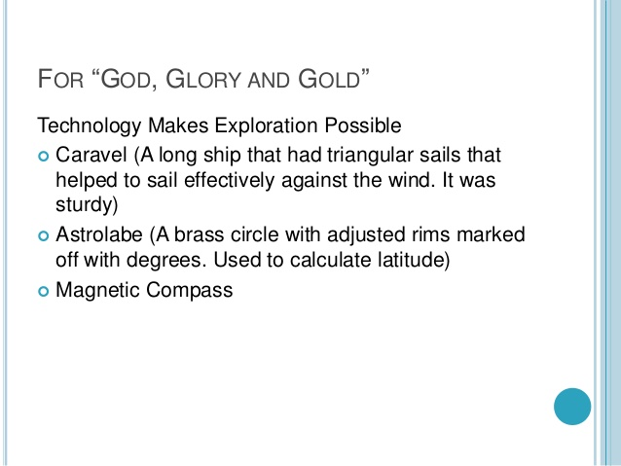
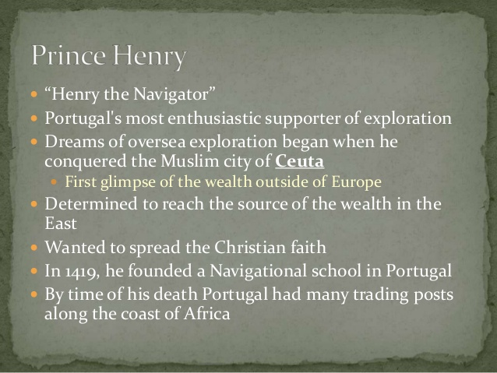
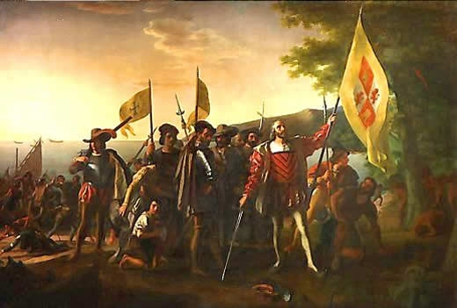

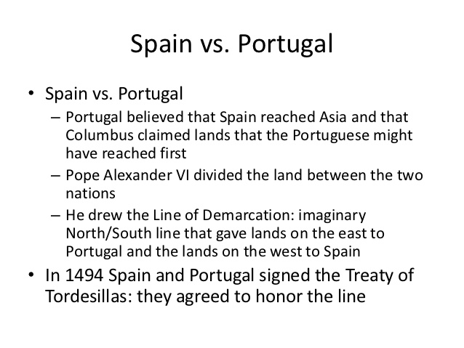
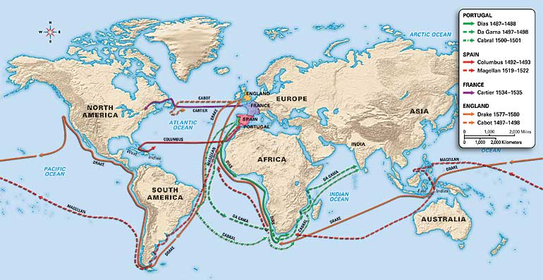
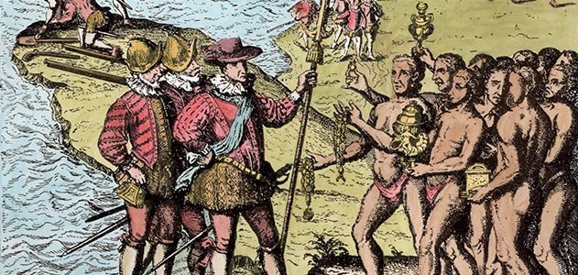
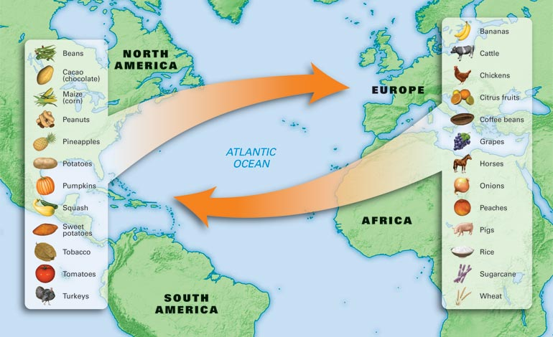
Reasons to Explore
Why did people set off to explore the world in the fifteenth century? First, they wanted Asian spices. Italy and Egypt controlled the trade routes to Asia, charging very high prices for spices. In fact, pepper cost more than gold. Many countries wanted to find a route to Asia so they could get spices without having to buy from Italian or Egyptian traders.
Religion gave explorers another reason to set sail. European Christians wanted to convert more people to their religion to counteract the spread of Islam in Europe, Africa, and Asia. Simple curiosity was also an important motivation for exploration. Many people read stories of Marco Polo’s travels and other explorers’ adventures. They learned about new lands and creatures, and they became curious about the world.

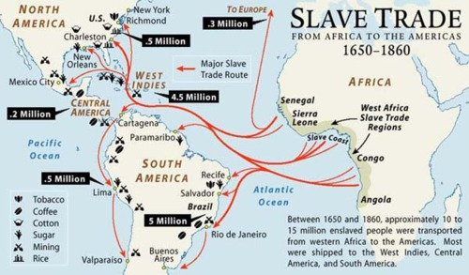
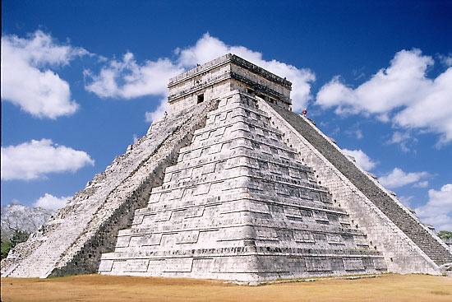
- Disease Kills Native Americans
  - With the arrival of the Europeans, the demand for slaves in the Americas increased significantly.
  - As disease reduced the native populations in Spanish conquered territories, the Spanish began relying on imported slaves from Africa for forced labor.

China and Japan Isolationism
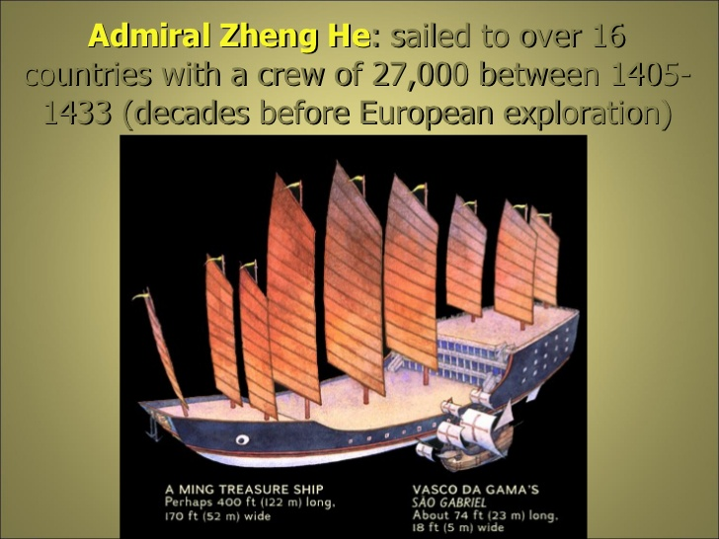
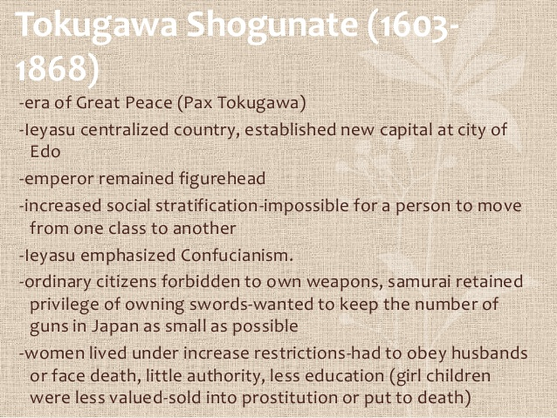
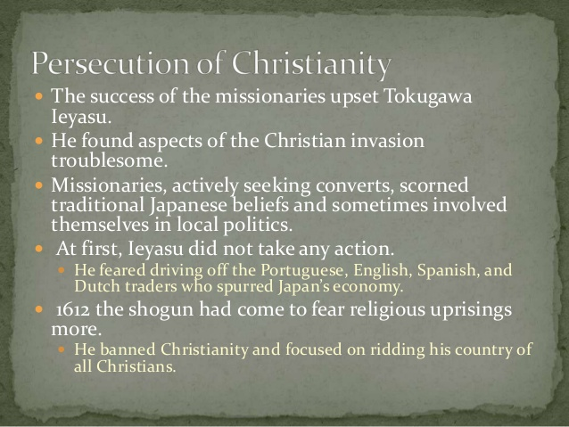
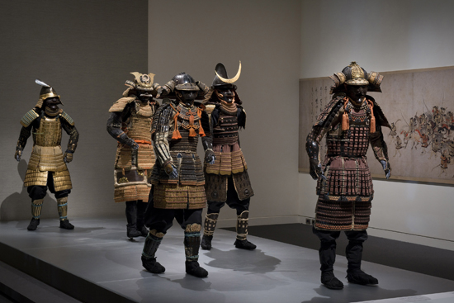

Absolute Monarchs of Europe
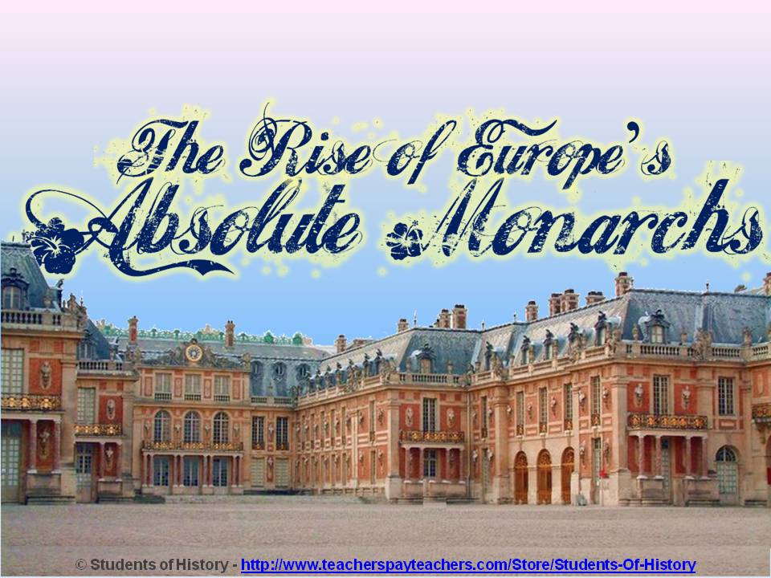
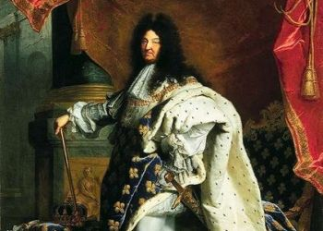
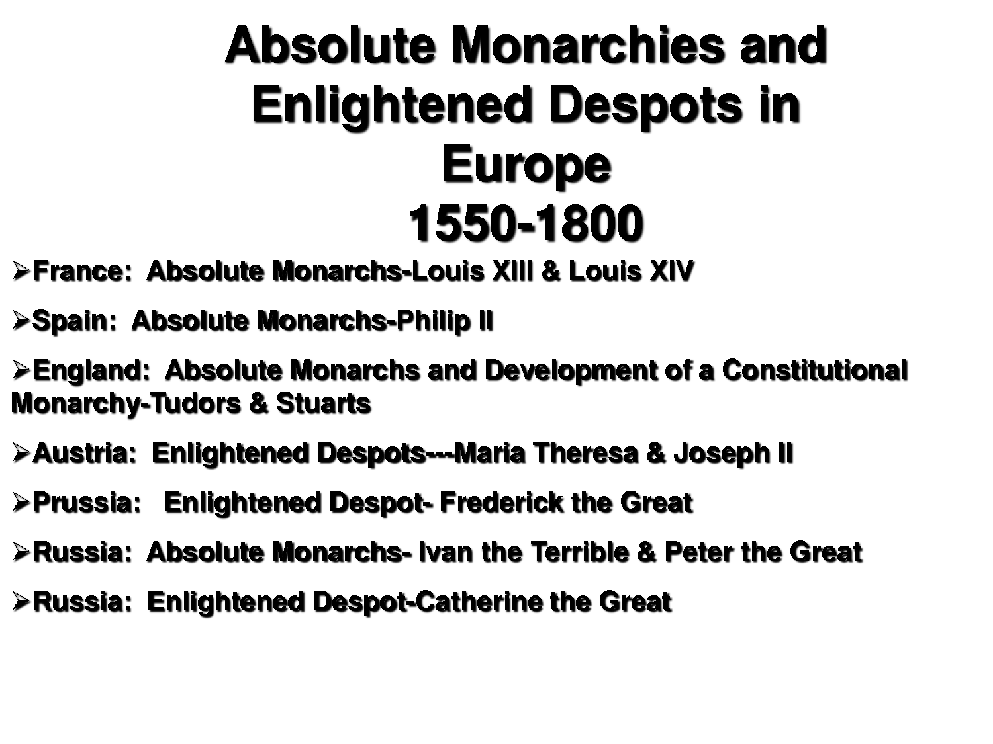
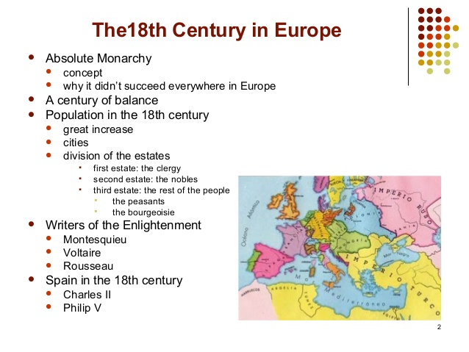

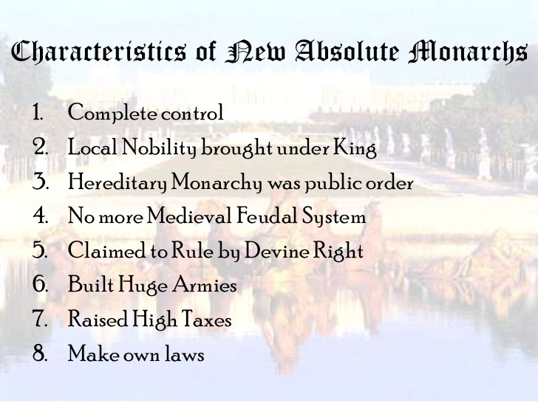
Enlightenment and Revolution
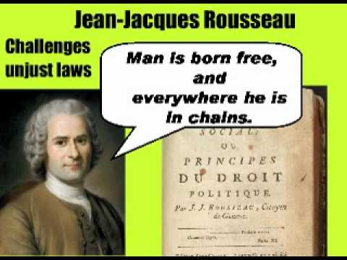
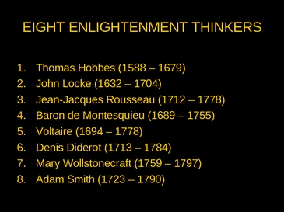
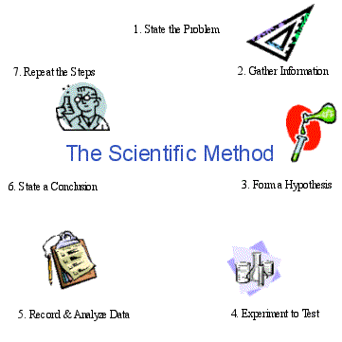
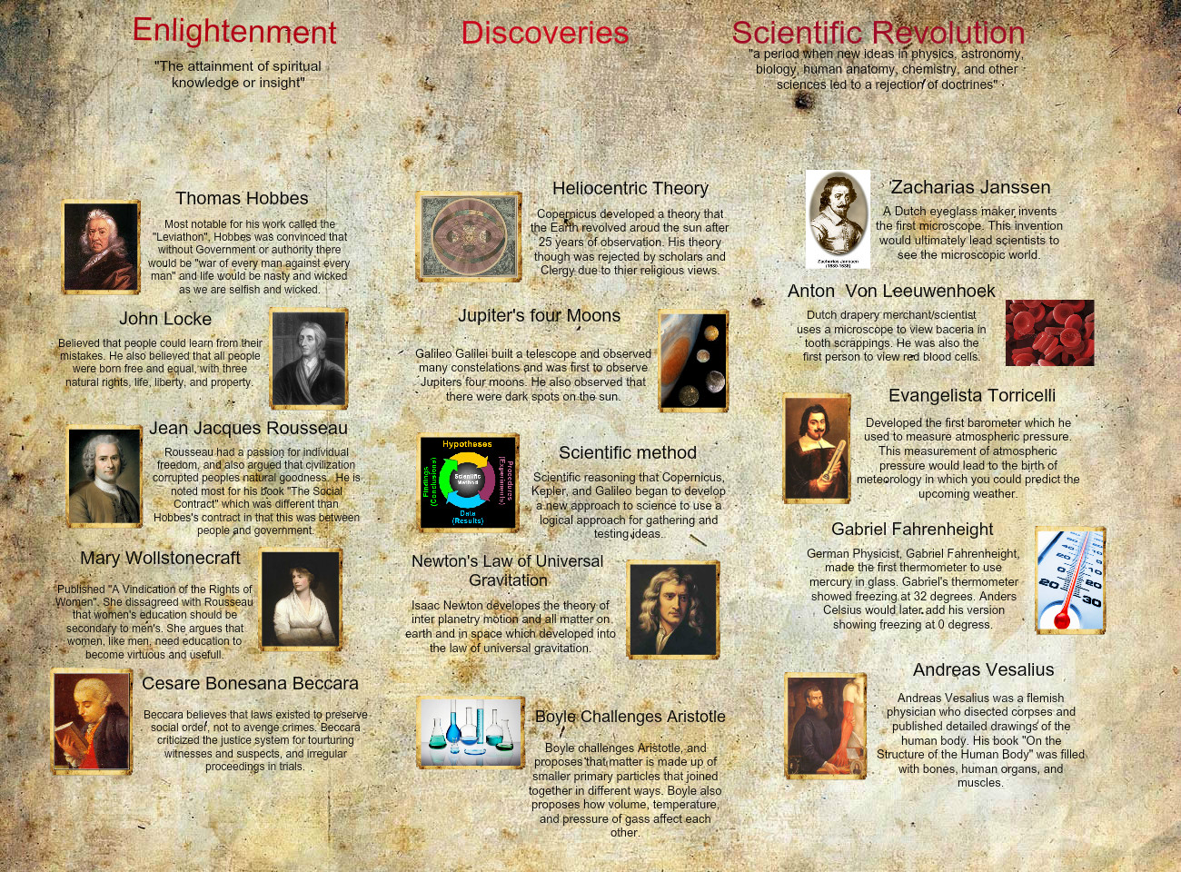
French Revolution –Napoleon Bonaparte

